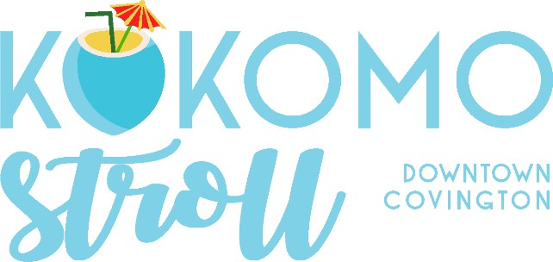

Saturday, July 12, 2025 6-9pm

STROLL STOP APPLICATION

The Covington Business Association is bringing the beach to Downtown Covington for the seventh annual Kokomo Stroll! This fun, festive event exists to draw people into Covington and promote awareness of local businesses. The stroll will take place on Saturday, July 12 from 6 - 9:00 PM (Rain or Shine). Participating CBA businesses will provide and serve 1,000 3-oz. samples of a craft beer or a summer-themed cocktail of their choice (all alcohol to be provided by CBA, per ATC regulation.

Each participating business must serve its beverage under a 10x10 tent OUTSIDE - either in the street or on the sidewalk. Per ATC regulation, no participating business may serve alcohol on their private property. Columbia Street will be closed to traﬃc, so businesses that do not have a storefront in the downtown area can participate by setting up a tent there. The event will include live music at various locations around Downtown Covington and beach-themed activities.

Current, paid CBA members can host a stroll stop for FREE.
I hereby apply as a stroll stop for the Kokomo Stroll.
Serving (Circle only one): FOOD TRUCK BEVERAGE
Circle beverage alcohol preferred: TEQUILA RUM VODKA CRAFT BEER
I am a current, paid CBA member (Circle one): YES NO

Contact Person:

Business Name:

Business Physical Address:

Email: Cell Phone:

Description of Beverage to Be Served (required):

Saturday, July 12, 2025 6-9pm

PLEASE READ THE GUIDELINES AND SIGN

- Applications for this year's event will be accepted and processed at https://www.gocovington.org/ The deadline for entries is Friday, June 28, 2025.
- Beverage stops are required to supply 1,000 3-oz. samples of a beach-themed cocktail.
(either tequila, vodka or rum provided by CBA), or 1,000 3-oz. craft beer samples (provided by CBA).
- Two food stops are limited to food trucks only.

Businesses must serve from 6:00 PM until the event ends at 9:00 PM.
- Businesses will not serve anyone without a stroll cup AND a wristband.
- Businesses will not serve alcoholic beverages to anyone under the age of 21.
- Businesses are encouraged to decorate their booth as creatively as they like!
- Businesses can promote their business by distributing marketing materials, etc.
- No businesses will be permitted to serve beverages on private property.
- Businesses must serve from under a 10x10 tent on the street or sidewalk, per ATC regulation.
- Booth placements TBA before the event for those who do not have a Storefront on or within proximity of Columbia Street.
- Electricity will be limited, and loud generators will not be permitted.
- The event is rain or shine.

Businesses must abide by all the guidelines.

I/we understand and agree to abide by all event guidelines.

Please print name

Date

Signature

Please return the completed application to: info@gocovington.org by June 28, 2025.

Additional details regarding logistics and setup to follow.

For questions, please contact event coordinator Cliff Bergeron at A Taste of the Town at 504.439.2543 or hello@kokomostroll.com or info@gocovington.com

